35.Write a Python program to draw a scatter plot comparing two subject marks
Aim:
To write a Python program to draw a scatter plot comparing the marks obtained by students in two subjects.
Program:
import matplotlib.pyplot as plt
subject1 = [75, 60, 85, 90, 55, 70, 80, 65, 95, 50]
subject2 = [80, 65, 88, 85, 60, 75, 78, 70, 92, 55]
plt.scatter(subject1, subject2)
plt.xlabel('Subject 1 Marks')
plt.ylabel('Subject 2 Marks')
plt.title('Comparison of Marks in Two Subjects')
plt.show()
Output:
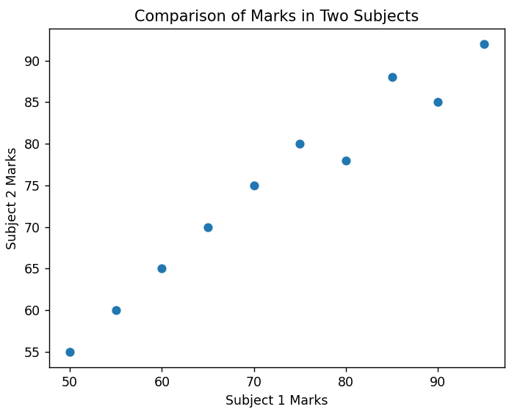
Result:
Thus, the Python program to draw a scatter plot comparing marks in two subjects was successfully executed.
36.Write a Python program to draw a scatter plot for three different groups comparing
weights and heights.
Aim:
To write a Python program to draw a scatter plot for three different groups, comparing their weights and heights.
Program:
import matplotlib.pyplot as plt
# Group 1
height1 = [150, 155, 160, 165, 170]
weight1 = [50, 55, 58, 62, 68]
# Group 2
height2 = [155, 160, 165, 170, 175]
weight2 = [52, 57, 61, 66, 72]
# Group 3
height3 = [160, 165, 170, 175, 180]
weight3 = [55, 60, 65, 70, 78]
plt.scatter(height1, weight1, label='Group 1')
plt.scatter(height2, weight2, label='Group 2')
plt.scatter(height3, weight3, label='Group 3')
plt.xlabel('Height (cm)')
plt.ylabel('Weight (kg)')
plt.title('Height vs Weight for Three Groups')
plt.legend()
plt.show()

Output:
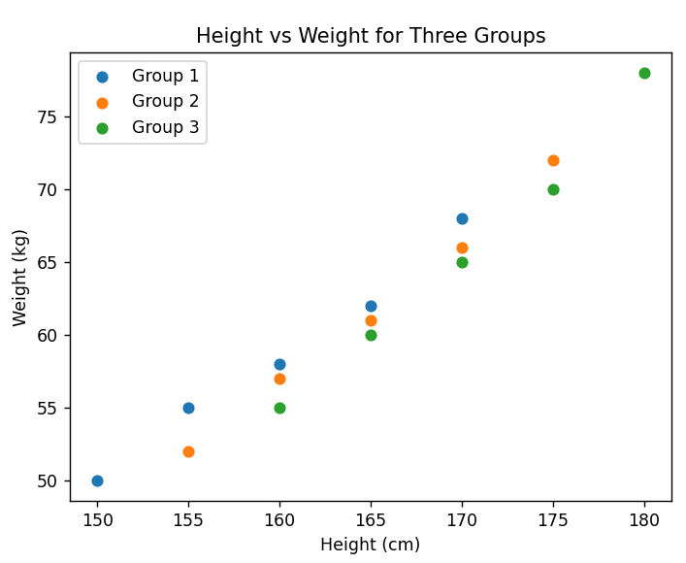
Result:
Thus, the Python program to draw a scatter plot comparing weights and heights for three different groups was successfully executed.

